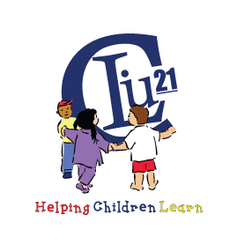
1st ANNUAL CARBON LEHIGH INTERMEDIATE UNIT 21 CAREER FAIR
Thursday, April 4, 2019
10:00am-12:00pm
REGISTRATION FORM
_____ Yes, we would like to participate.

_____ No, we are not able to participate this year.

(Please print or type)

COMPANY / AGENCY NAME: _______________

ADDRESS _______________

CITY, ZIP CODE _______________________________________________________________________________

CONTACT PERSON ____________________________

PHONE NUMBER__________________________________FAX NUMBER ______________________

E-MAIL ADDRESS______________________________________________________________________________

ALTERNATE CONTACT PERSON ________________________ ____________________________

PHONE NUMBER__________________________________FAX NUMBER ________

E-MAIL ADDRESS______________________________________________________________________________

REGISTRATION FORM MUST BE RECEIVED NO LATER THAN
Monday, March 25, 2019

Please e-mail Registration Form to Neal Graziano at grazianon@cliu.org
You may also fax the forms to (570) 443-0273.

Or mail to: Neal Graziano
85 Youth Forestry Lane
White Haven, PA 18661

